
2017 Ignite Heart Ball
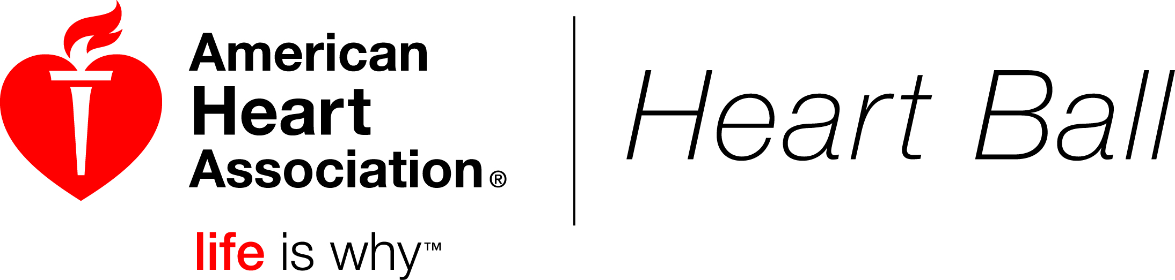
April 29, 2017
Auction Donation Form

_________________________________________________________________________________________________________
Business Name (List name as you would like to have it appear in the program):

____________________________________________ ______________________ ______________________________
Contact Name: Contact Phone: Contact Email:

_________________________________________________________________________________________________________
Address:

______________________________________________ ____________ _________________________________
City: State: Zip:

_________________________________________________________ ______________________________
Donor Signature: Date:
The amount deductible as a charitable contribution for federal income tax purposes is limited to the excess of the amount of the payment received over the fair market value of goods or services provided to the AHA.

❒ YES! We would like to donate [item(s) description]: ___________________________________________

______________________________________________________________________________________________
Restrictions:
_______________________________________________________________________________________________

_______________________________________________________________________________________________

Fair Market Value: $_____________

Please note that when the donation is a certificate, please make the expiration date in accordance to the event date, not the date of issue. Preferred expiration date is April 2018.

Benefits of Auction Donation
- Your name included in the Auction Program

The entire value of your donation is tax deductible
- Promotional value to an upscale market of potential customers

- The item is enclosed with promo materials for display boards.
- We will deliver the item to the AHA office with brochures by April 1, 2017

Please mail or fax completed form by April 1, 2017 to:
American Heart Association
Attn: Janet Lewis

5455 N. High St

Columbus, OH 43214
Phone: (614) 396-4362 Fax (614) 848-4227
E-mail: Janet.Lewis@heart.org
Federal Tax ID #: 13-5613797

